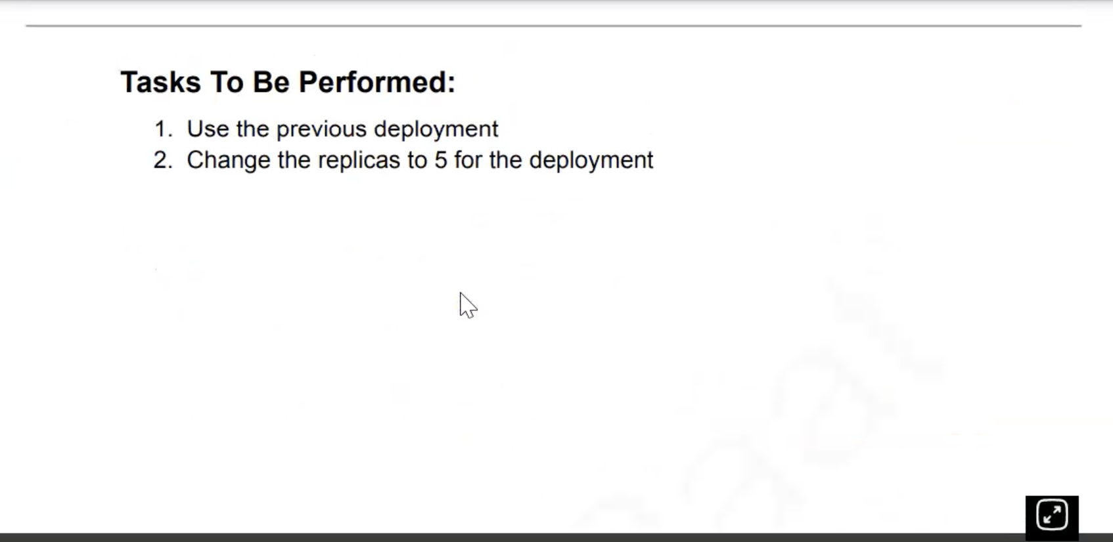

Run the command

Create the assignment3.yaml

And change the valure from 3 to 5

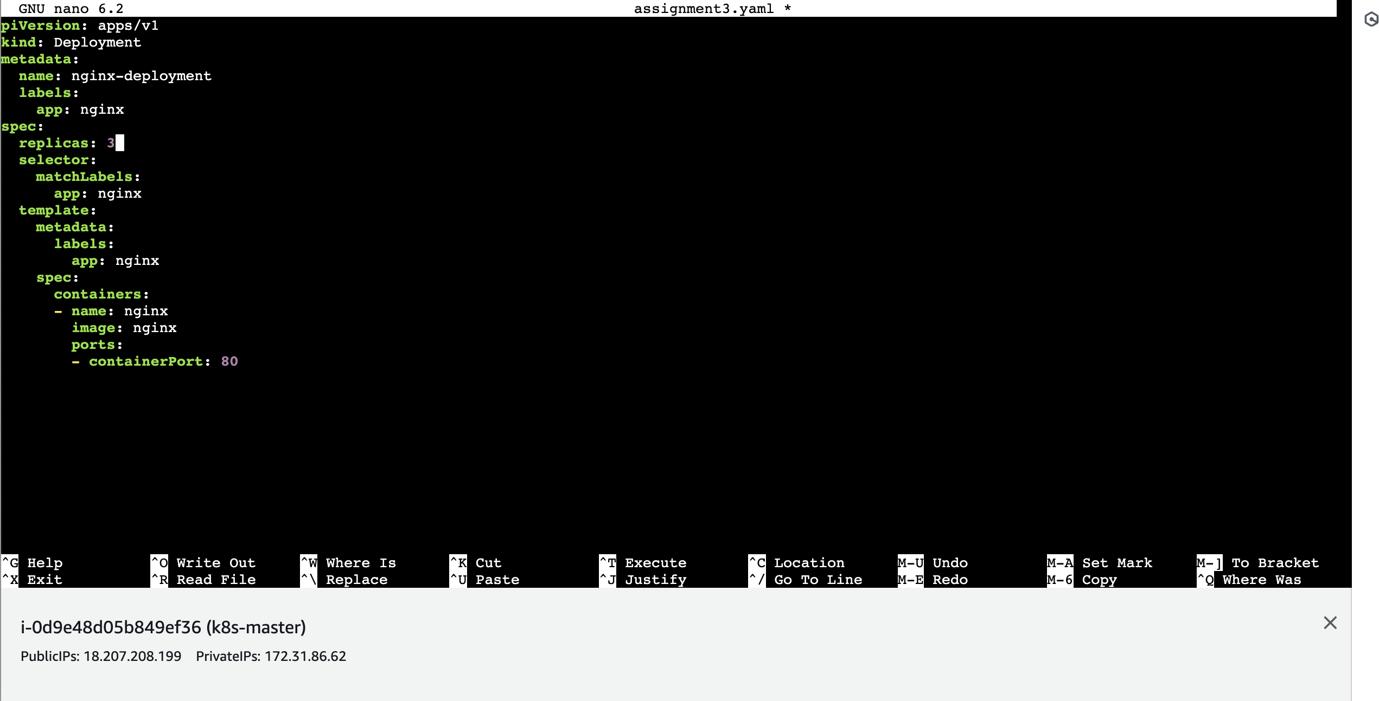

assign1.yaml assignmnet2.yaml

root@ip-172-31-86-62:/home/ubuntu# sudo nano assign1.yaml

root@ip-172-31-86-62:/home/ubuntu# sudo nano assignment3.yaml

root@ip-172-31-86-62:/home/ubuntu# ls

assign1.yaml assignment3.yaml assignmnet2.yaml

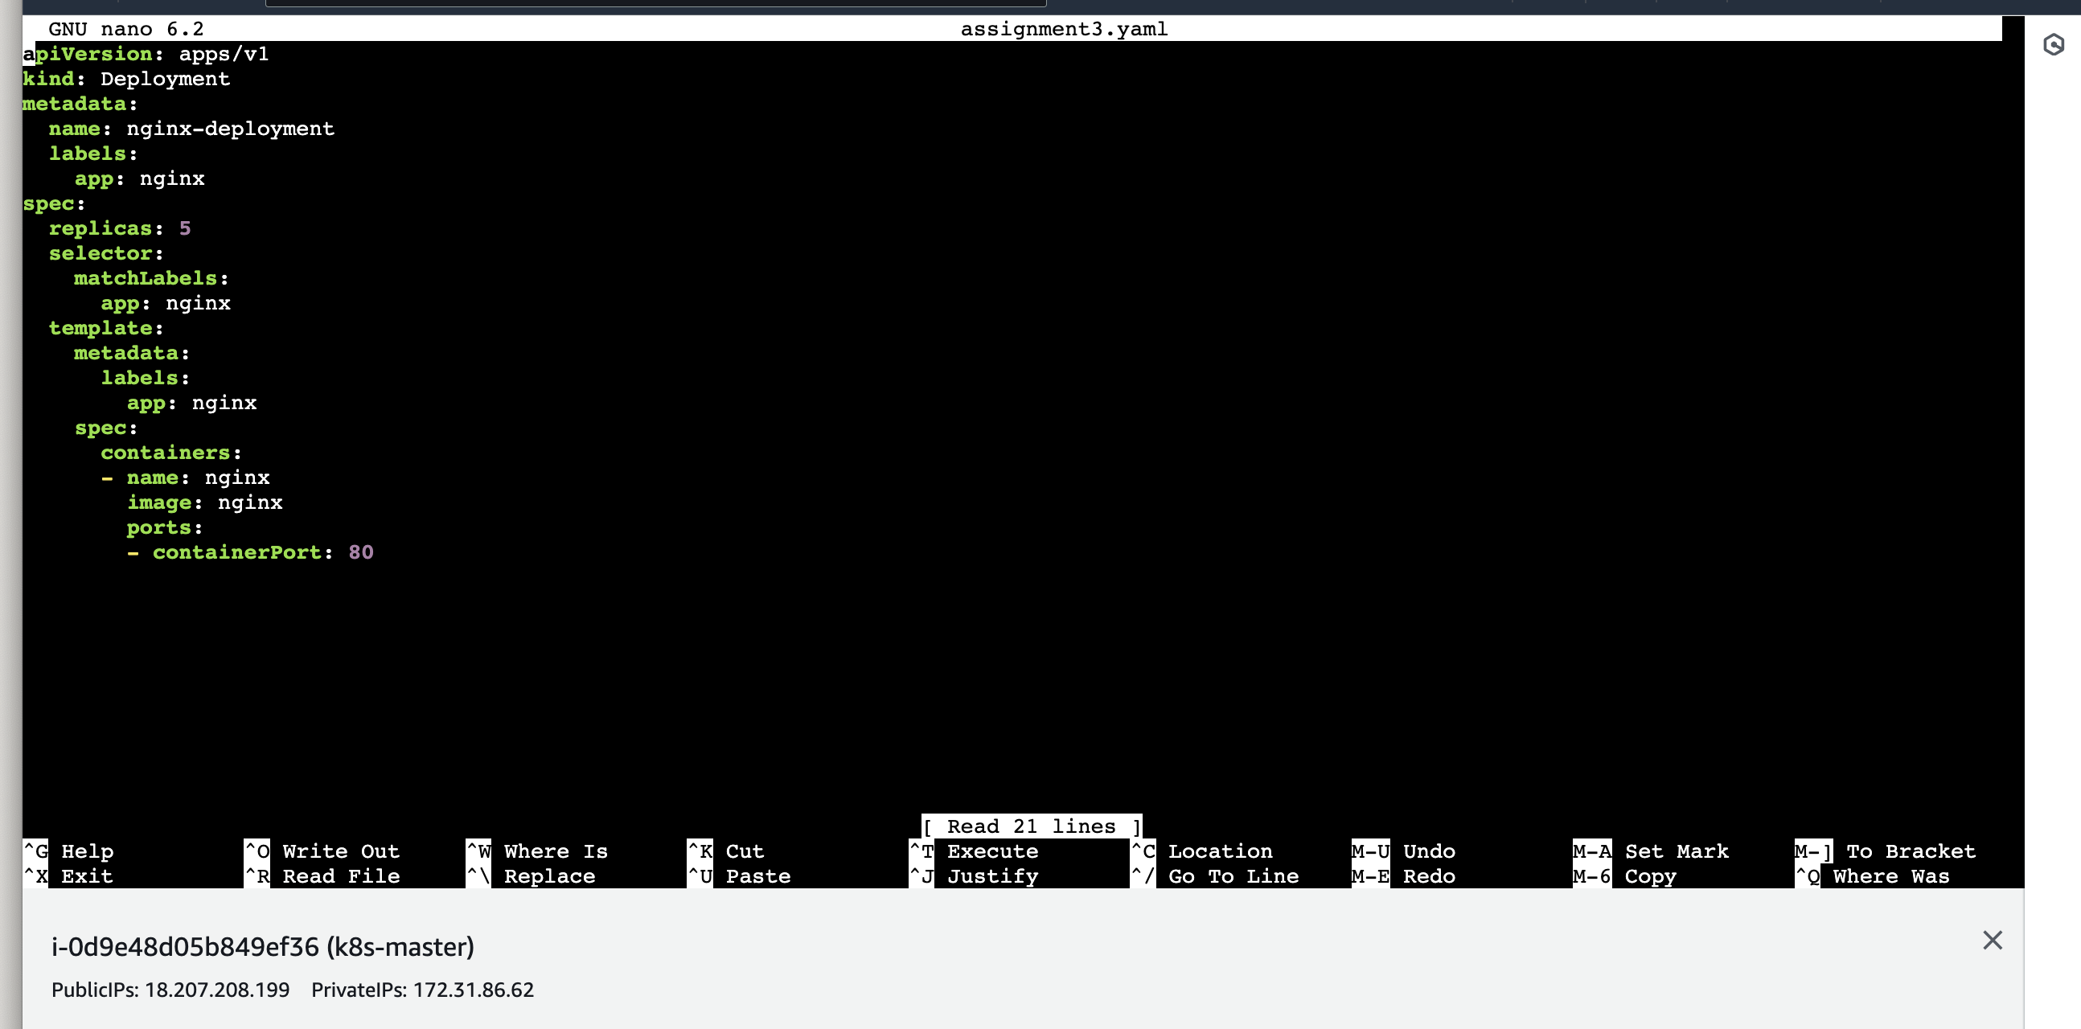

root@ip-172-31-86-62:/home/ubuntu# kubectl apply -f assignment3.yaml

deployment.apps/nginx-deployment configured.

root@ip-172-31-86-62:/home/ubuntu# kubectl get pod

NAME READY STATUS RESTARTS AGE

nginx-deployment-7c5ddbdf54-42xjt 1/1 Running 0 59m

nginx-deployment-7c5ddbdf54-9f7zg 1/1 Running 0 2m32s

nginx-deployment-7c5ddbdf54-bbwth 1/1 Running 0 59m

nginx-deployment-7c5ddbdf54-mf52f 1/1 Running 0 59m

nginx-deployment-7c5ddbdf54-s4tnt 1/1 Running 0 2m32s

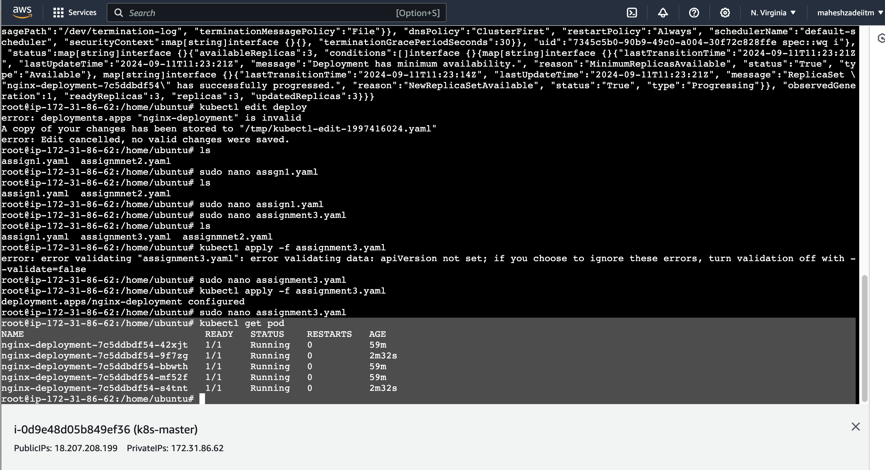

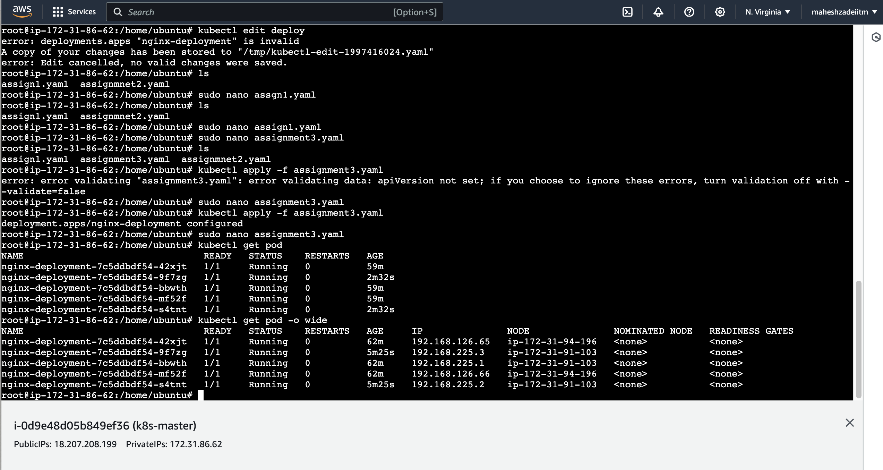

Replicas scaled up to 5 successfully .

Thanks